Active Directory Lab 12
DNS Troubleshooting – Break, Diagnose, and Fix

Objective
The objective of this lab was to troubleshoot DNS resolution in a Windows Server Active Directory environment. The lab involved first verifying that DNS was functioning correctly, intentionally changing the Windows 11 client's DNS server to an incorrect public DNS server, observing the resulting DNS failure, identifying the root cause using nslookup, ping, and ipconfig /all, and finally restoring the correct DNS configuration.
The goal was to understand the importance of DNS in an Active Directory environment and develop practical network troubleshooting and root-cause analysis skills relevant to SOC, IAM, and System Administration roles.

Lab Environment
Component | Details
Operating System (DC) | Windows Server 2019 (Domain Controller)
Operating System (Client) | Windows 11 Pro
Virtualization | Oracle VirtualBox
Domain | mydomain.com
DC IP Address | 172.16.0.1
Client IP Address | 172.16.0.50
Correct DNS Server | 172.16.0.1
Incorrect DNS Server | 8.8.8.8
Tools Used | nslookup, ping, ipconfig /all
Network | Internal Network

Part 1: DNS Verification and Break-Fix Scenario
Step 1: Starting the Virtual Machines
Procedure:
- Started the DC-Server VM.
- Logged in using:
Username: mydomain\Administrator
Password: P@ssw0rd123
- Started the Win11-Client VM.
- Logged in using:
Username: mydomain\Administrator
Password: P@ssw0rd123
- Verified that both VMs were connected to the same Internal Network.
Result:
Both the Domain Controller and Windows 11 client were successfully started and connected to the lab environment.

Step 2: Verifying DNS Before Breaking It
Before making any changes, DNS functionality was tested to establish a working baseline.
Procedure:
- Opened Command Prompt on Win11-Client.
- Executed:
nslookup mydomain.com
Expected Output:
Server: DC01.mydomain.com
Address: 172.16.0.1

Name: mydomain.com
Address: 172.16.0.1

Observation:
The Windows 11 client successfully contacted the internal DNS server and resolved mydomain.com to the Domain Controller's IP address.
Result:
DNS resolution was successfully verified.
Screenshot 2: Successful nslookup mydomain.com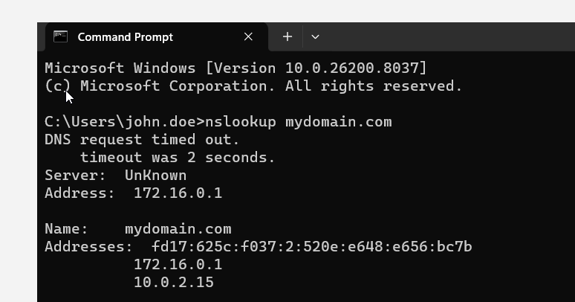

Step 3: Intentionally Breaking DNS
To create a controlled troubleshooting scenario, the client's DNS configuration was changed to an incorrect DNS server.
Procedure:
On Win11-Client:
- Opened Network and Internet Settings.
- Opened Advanced network settings.
- Selected More network adapter options.
- Right-clicked the Ethernet adapter.
- Selected Properties.
- Opened Internet Protocol Version 4 (TCP/IPv4).
- Selected Properties.
- Changed the Preferred DNS server from:
172.16.0.1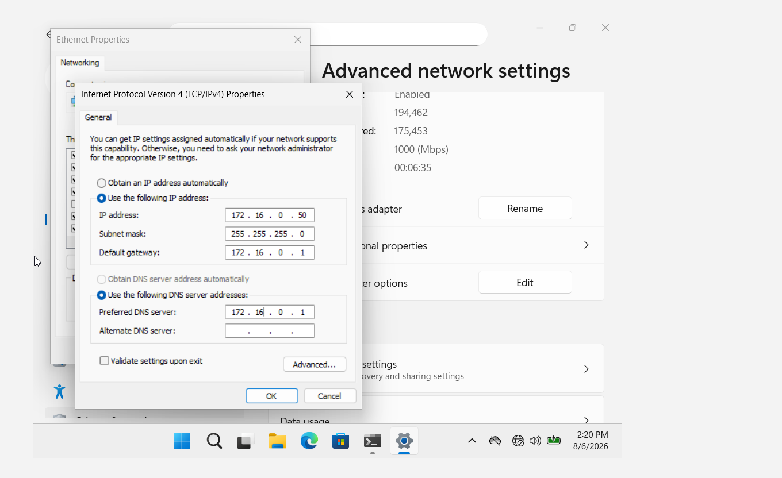
to:
8.8.8.8
- Clicked OK → Close.
Observation:
The client was now configured to use Google's public DNS server instead of the internal Active Directory DNS server.
Result:
DNS configuration was intentionally modified to create the troubleshooting scenario.

Part 2: DNS Failure Testing
Step 4: Testing DNS Using nslookup
After changing the DNS server, DNS resolution was tested again.
Procedure:
Executed:
nslookup mydomain.com

Expected Result:
DNS request timed out.
timeout was 2 seconds.

Server: UnKnown
Address: 8.8.8.8

*** Request to UnKnown timed-out
Observation:
The client attempted to send the DNS request to 8.8.8.8, but the internal domain mydomain.com could not be resolved.
Result:
DNS resolution failed. 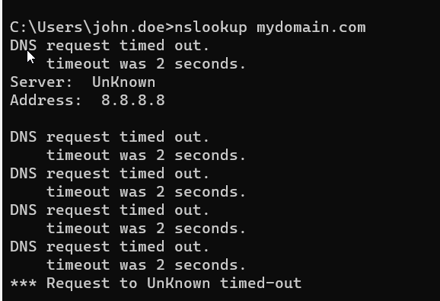

Step 5: Testing Domain Name Connectivity
The domain name was tested using the ping command.
Procedure:
Executed:
ping mydomain.com
Expected Result:
Ping request could not find host mydomain.com.
Please check the name and try again.
Observation:
The hostname could not be resolved to an IP address.
Result:
Hostname resolution failed.

Step 6: Testing Direct IP Connectivity
To determine whether the problem was related to general network connectivity or DNS specifically, the Domain Controller's IP address was pinged directly.
Procedure:
Executed:
ping 172.16.0.1
Expected Result:
Reply from 172.16.0.1: bytes=32 time<1ms TTL=128
Reply from 172.16.0.1: bytes=32 time<1ms TTL=128
Reply from 172.16.0.1: bytes=32 time<1ms TTL=128
Observation:
The client successfully communicated with the Domain Controller using its IP address.
Result:
Network connectivity was confirmed to be working.

Part 3: Troubleshooting and Root Cause Analysis
Step 7: Checking Network Configuration
The client's network configuration was inspected to identify the DNS server being used.
Procedure:
Executed:
ipconfig /all
Observation:
The DNS Server entry showed:
DNS Servers . . . . . . . . . : 8.8.8.8
Result:
The incorrect DNS configuration was identified.

Root Cause
The Windows 11 client was configured to use:
8.8.8.8
as its DNS server.
However, the Active Directory domain:
mydomain.com
is an internal/private domain whose DNS records are hosted by the Domain Controller at:
172.16.0.1
The client was therefore querying the wrong DNS server.
Root Cause Identified:
The client's DNS server was incorrectly configured as 8.8.8.8 instead of the internal Domain Controller DNS server 172.16.0.1.

Part 4: Fixing DNS
Step 8: Restoring the Correct DNS Server
Procedure:
- Opened IPv4 Properties on Win11-Client.
- Changed the Preferred DNS server from:
8.8.8.8
back to:
172.16.0.1
- Clicked OK.
- Clicked Close.
Result:
The Windows 11 client was once again configured to use the internal Active Directory DNS server.
Screenshot 8: Corrected DNS configuration showing 172.16.0.1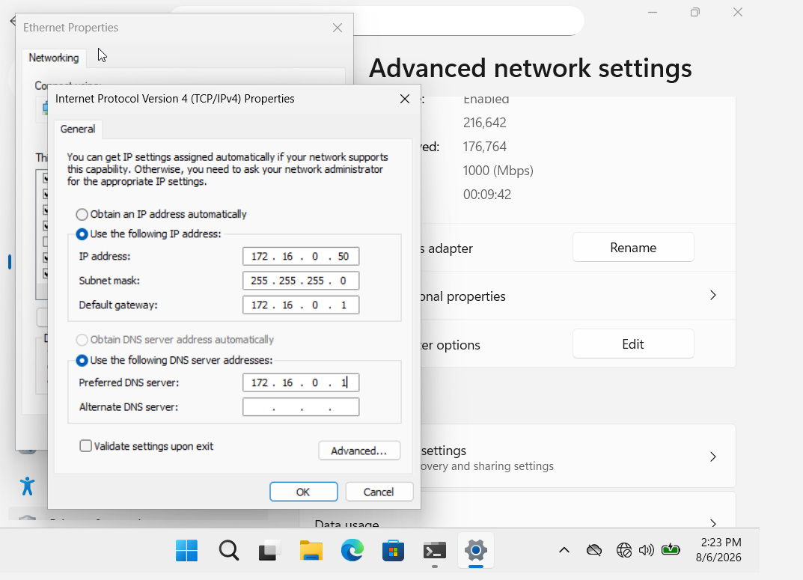

Part 5: Final Verification
Step 9: Testing DNS After the Fix
Test 1 – nslookup
Executed:
nslookup mydomain.com
Expected Output:
Server: DC01.mydomain.com
Address: 172.16.0.1

Name: mydomain.com
Address: 172.16.0.1
Observation:
The domain name was successfully resolved by the internal DNS server.
Result:
DNS resolution restored successfully.

Test 2 – Ping Domain
Executed:
ping mydomain.com
Expected Output:
Pinging mydomain.com [172.16.0.1] with 32 bytes of data:

Reply from 172.16.0.1: bytes=32 time<1ms TTL=128
Reply from 172.16.0.1: bytes=32 time<1ms TTL=128
Reply from 172.16.0.1: bytes=32 time<1ms TTL=128
Observation:
The hostname was successfully resolved to 172.16.0.1, and the Domain Controller responded to the ping.
Result:
DNS and network connectivity were successfully restored.

Troubleshooting Summary
Challenge | Root Cause | Solution
nslookup mydomain.com failed | Client was using 8.8.8.8 | Changed DNS to 172.16.0.1
ping mydomain.com failed | Domain name could not be resolved | Restored internal DNS
ping 172.16.0.1 worked | Network connectivity was functioning | Confirmed issue was DNS, not network
ipconfig /all showed wrong DNS | Incorrect IPv4 DNS configuration | Changed DNS server back to 172.16.0.1

Key Takeaways
Test | What It Demonstrated
nslookup mydomain.com | DNS name resolution
ping mydomain.com | DNS + network connectivity
ping 172.16.0.1 | Direct IP connectivity
ipconfig /all | DNS and network configuration
8.8.8.8 | Incorrect DNS server for internal domain
172.16.0.1 | Internal Active Directory DNS server

Important Troubleshooting Logic
The most important part of this lab was comparing the results:
ping 172.16.0.1
↓
✅
Network connectivity works
ping mydomain.com
↓
❌
Hostname resolution fails
nslookup mydomain.com
↓
❌
DNS resolution fails
Therefore:
The network was working, but DNS resolution was broken.
This is a useful troubleshooting methodology because it prevents incorrectly blaming the network when the actual issue is DNS configuration.

Skills Demonstrated
- DNS Troubleshooting
- Active Directory DNS
- Windows Server Administration
- Windows 11 Administration
- Network Troubleshooting
- DNS Configuration
- nslookup
- ping
- ipconfig /all
- Root Cause Analysis
- Break-and-Fix Troubleshooting
- Domain Name Resolution
- Network Diagnostics

Conclusion
This lab provided practical experience with DNS troubleshooting in a Windows Server Active Directory environment.
The DNS configuration was first verified to establish a working baseline. The Windows 11 client's DNS server was then intentionally changed from the internal Domain Controller (172.16.0.1) to the public DNS server (8.8.8.8), resulting in failed resolution of the internal mydomain.com domain.
Through the use of nslookup, ping, and ipconfig /all, the issue was isolated to DNS rather than general network connectivity. The root cause was identified as an incorrect DNS server configuration on the Windows 11 client.
The DNS configuration was restored to 172.16.0.1, after which domain name resolution and connectivity were successfully verified.
The lab strengthened practical skills in DNS troubleshooting, network diagnostics, root-cause analysis, and Active Directory administration, which are valuable for SOC Analysts, IAM Analysts, and System Administrators.

